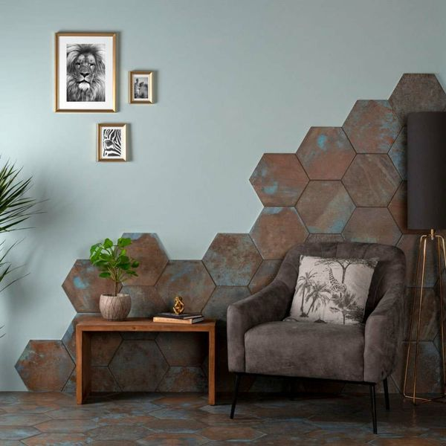**Oaken Teal Oxidised Hexagon Tiles:**

## **Product Description**

For a characterful new look in your home, introduce these Oaken Hexagon Tiles to the wall and floor spaces. They have a weathered rusty look; like oxidised metal - perfect for bringing a reclaimed industrious look into a bathroom, kitchen or living area! Create a statement floor or feature wall.

**What's special about these tiles?**

> Characterful oxidised look

> Perfect for an industrial scheme

> Trendy hexagonal shape

> Made from durable porcelain

> Suitable for walls and floors

> Can be used with underfloor heating

**Take a closer look**

Want to take a closer look at these tiles before placing a full order? Why not order a sample tile? We send samples out with free delivery! They're the perfect way to see what a tile looks like in position in your home.

## **Product Info**

* Product ID: 43852
* Tiles Per SQM: 14.310684840116
* Sale by: Per SQM
* Size: 280x333x9mm
* Weight: 1.33 KG
* Material Type: Porcelain
* Finish: Matt
* Colour: Brown
* Suitability: Floors, Walls
* Grade: 3
* Rectified Edge: No
* Underfloor Heating: Yes
* Thickness (mm): 9